Atharv Arya 1BM18CS020

PROGRAM TITLE: IR REMOTE

Aim: DESIGN IR based SERVO MOTOR controller (Clockwise and counterclockwise Rotation of shaft)

Hardware Required:

* IR remote
* IR sensor
* Micro Servo
* Breadboard
* Arduino UNO Circuit Diagram:

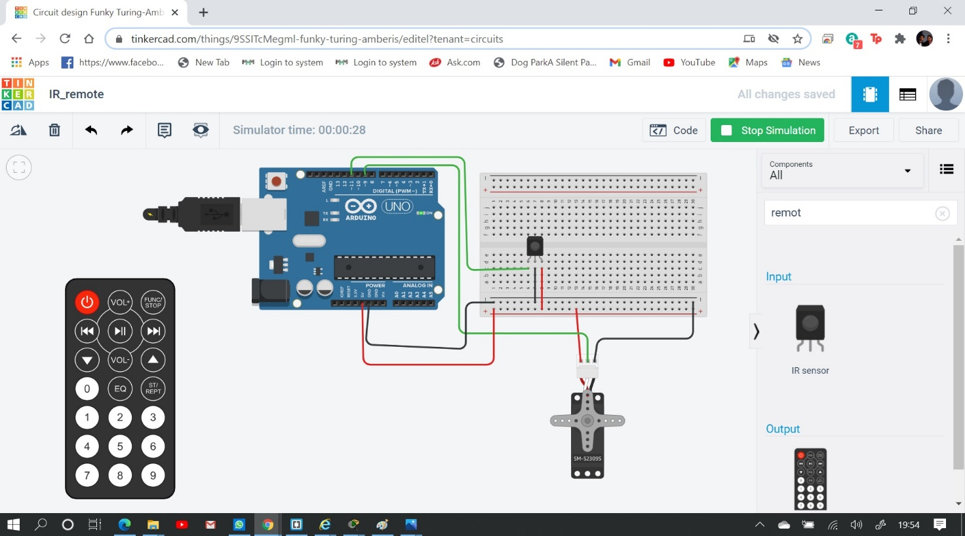

Write-Up:

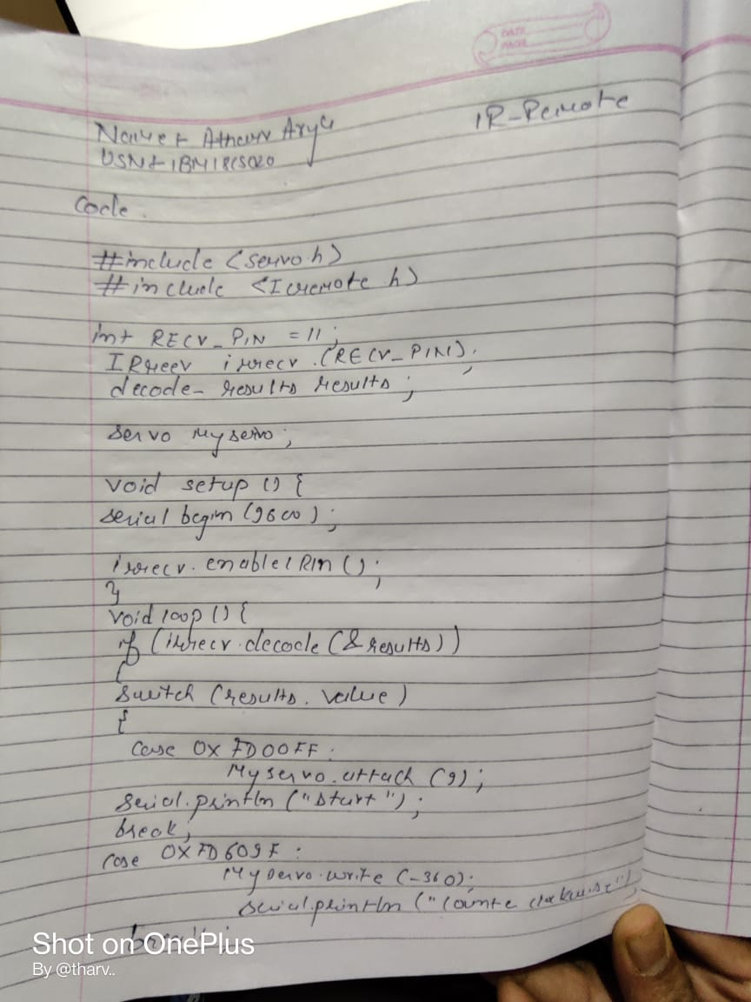

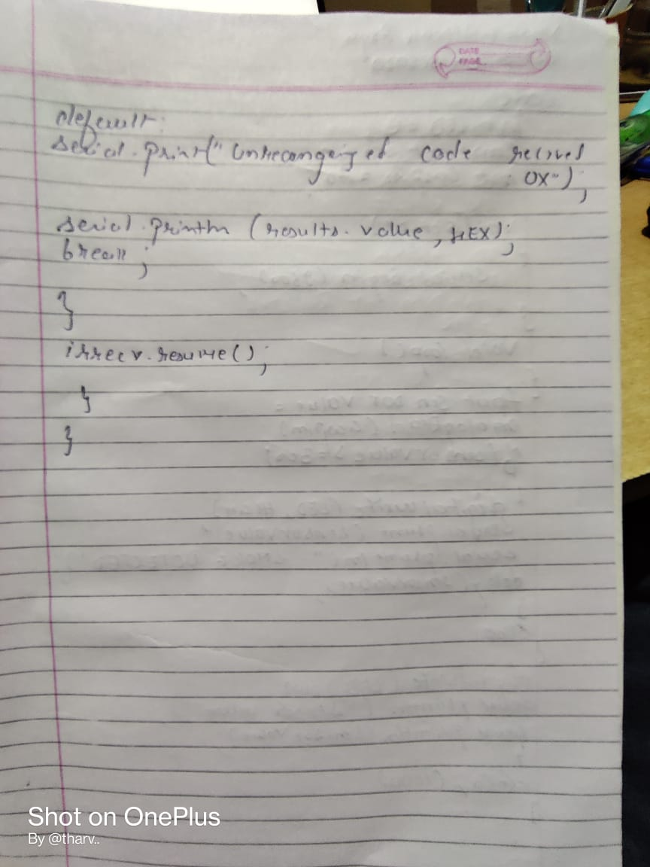

CODE:

#include <Servo.h> #include <IRremote.h>

int RECV_PIN = 11;

IRrecv irrecv(RECV_PIN); decode_results results;

Servo myservo;

void setup(){ Serial.begin(9600);

irrecv.enableIRIn();

}

void loop(){

if (irrecv.decode(&results))

{

switch (results.value)

{

case 0xFD00FF:

myservo.attach(9); Serial.println("Start"); break;

case 0xFD609F:

myservo.write(360); Serial.println("Clockwise");

break;

case 0xFD20DF:

myservo.write(-360); Serial.println("Counter Clockwise");

break; default:

Serial.print("Unrecognized code received: 0x"); Serial.println(results.value, HEX);

break;

}

irrecv.resume();

}

}

Output/Observation:

Start

Counter Clockwise Clockwise

Unrecognized code received: 0xFFFFFFFF